Group 2 Software Product Management Plan

Version 2.1

Alec Totushek

Braeden Dorsey

Ksenia Tepliakova

Nick Homayouni

Tan Duong

Table of Contents

Changelog 2

0. Preface 2

0.1. Scope 2

0.2. Purpose 2

1. Introduction 2

1.1. Overview 2

1.2. Deliverables Schedule 3

1.3. Evolution 3

1.4. Definitions 3

1.5. References 4

2. Organization 4

2.1. Software Process and Model 4

2.2. Organizational Structure and Interfaces 5

2.3. Project Responsibilities 5

2.4. Gantt Chart 7

3. Management 7

3.1. Objectives and Priorities 7

3.2. Assumptions, Dependencies, and Constraints 7

3.3. Risk Assessment 8

3.4. Monitoring and Controlling Mechanisms 9

4. Technical Process 9

4.1. Methods, Tools, and Techniques 9

4.2. Documentation Plan 9

4.3. Project Support Functions 10

5. Work Breakdown Structure 11

# Changelog

2.0

* Added Gantt chart
* Modified and added to section Documentation Plan
* Added new plugins to section Methods, Tools, and Techniques
* Minor grammatical fixes

2.1

* Added to section Definitions
* Added to section Methods, Tools, and Techniques

# 0. Preface

## 0.1. Scope

This document will cover the plan that will be followed in order to complete this project efficiently and in a timely manner. This plan will be followed by all members of the team to ensure that collaboration is achieved and that the final product is consistent in its design. This will guarantee that all requirements are met for this project so that the final product will be complete.

## 0.2. Purpose

This document provides an outline of the tools, methods, and processes necessary for completion of the project. This document also outlines roles and responsibilities of each group member, schedules, deadlines, and possible risks or drawbacks.

# 1. Introduction

## 1.1. Overview

The goal of this project is to produce a web application that allows users to play a fitness-based jeopardy game. Users will answer fitness-based questions and perform activities to receive points. User’s scores and records will be stored in a database and be available for certain designated parties, such as parents, to view. These designated parties will also be able to provide feedback to project group members. Jeopardy boards in the game will be updated frequently and randomized in order to ensure that the game stays interesting. The purpose of this game is to engage users to educate them about fitness and wellness while also getting them to be active. This application will be collaborated on by all members using WordPress as the host platform.

## 1.2. Deliverables Schedule

Deliverable Due Date

|  |  |
| --- | --- |
| Requirements and Use Case Analysis | 02/17/2020 |
| Repository Creation | 02/21/2020 |
| SPMP | 02/24/2020 |
| Unit and Integration Test Skeletons | 03/09/2020 |
| End-To-End and Regression Test Procedures | 03/09/2020 |
| Group Project Review | 03/23/2020 |
| Application Testing | 03/30/2020 - 04/20/2020 |
| Finished Application | 04/27/2020 |

## 1.3. Evolution

Setbacks or a change-in-plans may occur during the production of the application, and as such, this document may undergo adjustments. In the case that change occurs, time will be allotted to discuss the effects of said change, and this document will be adjusted accordingly. If and when this document is changed, a changelog section will be added detailing the changes made, and the updated document will be pushed to the repository with a new version number.

## 1.4. Definitions

**GUIs (Graphic User Interfaces)** - A system of interactive visual components for computer [software](https://www.computerhope.com/jargon/s/software.htm). A GUI displays objects that convey information, and represent actions that can be taken by the user. The objects change color, size, or visibility when the user interacts with them.

**MySQL** - An open-source relational database management system.

**MySQL WorkBench** - A visual database design tool that integrates SQL development, administration, database design, creation and maintenance into a single integrated development environment for the MySQL database system.

**Namecheap** - A popular ICANN-accredited domain name registrar, takes the responsibility of providing the domain name registration and web hosting

**Plugins** - A piece of software containing a group of functions that can be added to a WordPress website.

**Simmer.io –** A free online service that allows hosting of Unity WebGL applications.

**Unity –** A cross-platform game engine used to create applications.

**WordPress** - A widely popular, open-source content management system that is used for simple web development.

## 1.5. References

Design validation and verification process Guru 99: <https://www.guru99.com/design-verification-process.html>

# 2. Organization

## 2.1. Software Process and Model

For this project, an iterative process will be used. An iterative model lends itself best to this project due to the fact that various aspects of this project build on one another. Below is a model of how this process will be utilized.

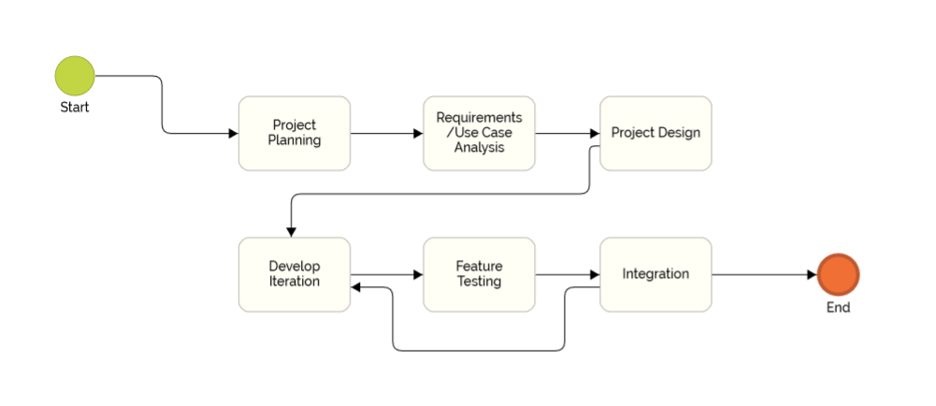

## 2.2. Organizational Structure and Interfaces

Group Member Role

|  |  |
| --- | --- |
| Alec Totushek  atotus1@students.towson.edu | Organizational Lead - Keep track of schedules, deadlines, and documentation |
| Braeden Dorsey  bdorse8@students.towson.edu | Project Developer - Working on creating the website and ensuring it functions as intended and required |
| Ksenia Tepliakova  ktepli1@students.towson.edu | Game developer and researcher - research and integrate methods and tools to develop a desired game application |
| Nick Homayouni  nhomay1@students.towson.edu | Game developer and researcher - research and integrate methods and tools to develop a desired game application |
| Tan Duong  tduong2@students.towson.edu | Project Developer - Working on website based on the designed and schedules |

## 2.3. Project Responsibilities

Phase Description Group Member(s)

|  |  |  |
| --- | --- | --- |
| Planning | Develop an idea that fits project guidelines | All |
| Requirements and Use Case Analysis | Analyze functional and non-functional requirements for the project as well as well as possible use cases for the application | Alec Totushek |
| Unit and Integration Test Skeleton Creation | Unit testing is necessary to ensure that each unit is working properly before integration. Integration testing is necessary to ensure that each unit and plugin is functioning correctly with each other. | Braeden Dorsey  Ksenia Tepliakova |
| End-To-End and Regression Test Procedure Creation | E2E: Analyze and review the workflow of the app; Describe the inputs and methods of the system; Expect the real-time loads and Develop the Testing Series.  Regression: | Nick Homayouni  Tan Duong |
| Project Design | Transfer requirements and use cases to software design outline | Ksenia Tepliakova  Nick Homayouni |
| Project Development | Develop the application based on project design | Braeden Dorsey  Tan Duong |
| Database Management | Creation and management of the database where user data will be stored | Alec Totushek  Braeden Dorsey |
| Testing | Confirm that the aspects of the product function as intended as individual units and as a whole application | All |
| Documentation | Document results of design, development, and testing as well as creation of a user’s manual | Alec Totushek |

## 2.4. Gantt Chart

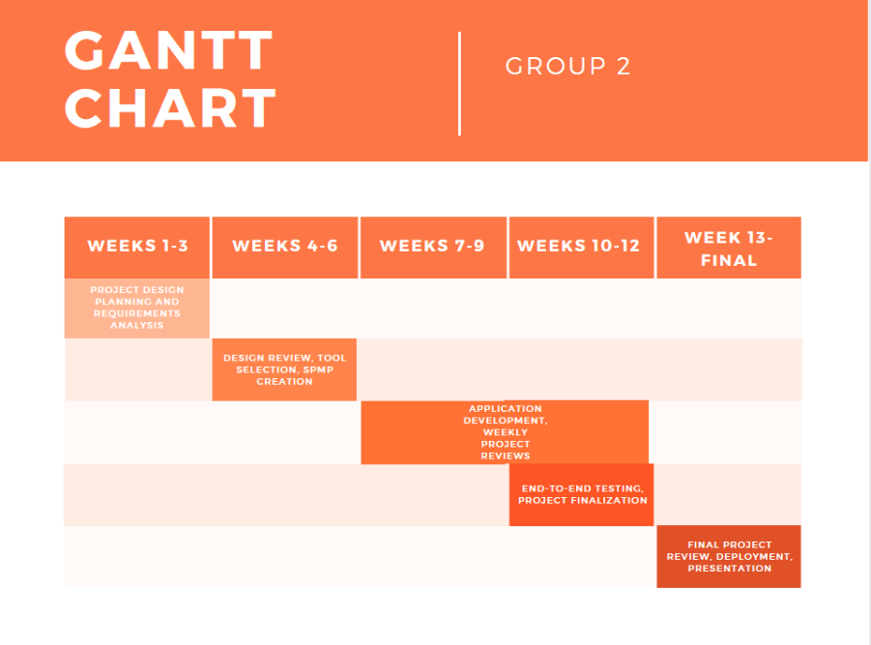

# 3. Management

## 3.1. Objectives and Priorities

Our goal is to develop a working platform that would satisfy requirements of the project that are supposed to push students to learn about a healthy lifestyle, develop fitness habits and knowledge about healthy diet. Our vision is to create friendly interfaces for phones, personal computers or tablets. To achieve this goal, we created a discord group to communicate with each other. In person meetings are not necessary for this project as far as each group member can complete their task.

## 3.2. Assumptions, Dependencies, and Constraints

* This project will include a web-based application
* The product will allow for future expansion, which will be detailed in documentation
* At least two players are necessary to use the application
* The length of the semester is a time constraint

## 3.3. Risk Assessment

The goal of risk assessment for this project is to predict possible risks or issues that may occur, and find a way to mitigate or alleviate the impacts that may occur as a result. Some of these risks are common to most long-term projects, while others are specific to what we are building. The possible risks are as follows:

* **Team Members are unavailable.** Due to the current Covid-19 outbreak, society and school/work in our community has changed immensely. Due to these sweeping changes to our general way of life, members may not be able to perform given tasks when the schedule says to. In order to mitigate this, our group has a discord group chat, and if a member is going to be unavailable temporarily due to the circumstances, they are to alert the group and those available will adjust.
* **Miscommunication.** As with any project with multiple members, sometimes the design or plan one member has is not the same as the design and plan another member has. A group must all be on the same page and be working toward the same end product. In order to avoid miscommunication, our group has a set schedule, and a discord group chat to bounce ideas off of each other and keep everything organized and uniform.
* **Lack of experience with these softwares.** As a group, we have very little experience in using Wordpress and creating/designing websites and GUIs in general. We also have little to no experience in game creation. The only portion of this project in which group members have a solid foundation would be in the creation and management of databases, which will be used for storing account information and progress records. In order to overcome this lack of experience, we will be using google extensively for guides and help, as well as testing individual pieces of the software as we create them, to make sure it functions as intended before putting it all together.
* **Faulty Design.** Errors in code and in software structure are a common risk that can derail an entire project off of a simple typo or mistake. In order to mitigate these mistakes, we will be testing each individual section of code and functions to make sure they work as intended before we put it all together.

## 3.4. Monitoring and Controlling Mechanisms

As a progress monitoring mechanism we are scheduling an online session once a week to track our progress to make sure that we are following the schedule. During those sessions we discuss what needs to be done for the following week and if any of the team members need help during the current stage.

# 4. Technical Process

## 4.1. Methods, Tools, and Techniques

To create the site itself our team will be using Wordpress, with our domain hosting being handled by Namecheap. Wordpress was chosen due to its availability, versatility, plus the wide array of plugins which add functions and capabilities which we are sure we will need for the project. The plugins being used include:

* Elementor and WPForms Lite: Used to give the site a more welcoming, eye-catching look and style. It will allow us to create forms, text boxes, and sign-in boxes using a drag-and-drop feature.
* Really Simple SSL and WP Force SSL: Used to give the website an HTTPS connection.
* WooCommerce and CartFlows: Used to create selling offers and checkout pages.

For database creation and management (for account information and progress records) we will be using MySQL and MySQL Workbench. This database will be hosted using an external application called MAMP.

The application itself will be made with Unity, and will be hosted online using the service Simmer.io. Unity was chosen due to is availability and wide range of tutorials online. Simmer.io was chosen to host the application due to its availability and ease of use.

## 4.2. Documentation Plan

Design Documentation:

* During the design phase, documentation will include original design plans and any revisions made to the original design.

Development Documentation:

* During the development phase, each iteration of the product will be documented on. Documentation will include how it interacts with other parts of the application as well as the results of testing.

Other Documentation:

* Other documents—such as this SPMP, requirements outline, and test skeletons—will be updated when necessary with appropriate version numbers, and if appropriate, a changelog.

## 4.3. Project Support Functions

Quality Assurance Plan: Several steps to ensure a quality product include:

* A review meeting in which the product is tested by both internal and external stakeholders to listen for their comments and validation.
* A code inspection review consisting of static testing to find bugs and prevent errors in later stages.
* A design inspection review in which a checklist is used to inspect areas of design such as interface specifications, logic, performance, error handling and recovery, and testability.
* Simulation/Walkthrough review to examine behavior of the system under real-life conditions and a peer review where the developer walks through the product with the rest of the group to bring up concerns, alternatives, and any other issues.

Configuration Management Plan: The purpose of this plan is to periodically manage and organize the changes in documentation and code. We want to increase productivity with little to no errors. The tasks included in this plan include:

* Configuration Identifying: describing the structure of source code modules, test cases, and requirement specification as well as making sure every object and function has its own features that clearly identify its purpose.
* A baseline (reference point) version which serves as the basis of the application. Constructing and managing various versions of the product to correspond to the functional requirements.
* A change control method which ensures quality whenever changes are made to the documentation or code. Changes must be committed to the github repository and will be reviewed by each member of the group.
* A configuration status accounting which keeps records of changes made to previous versions and can be accessed at any time.
* Configuration Reviews which get checked to ensure that the requirements are being satisfied and changes made abide by the configuration status reports.

Verification and Validation Plan:

* Continuously monitor the design which enables us to meet the user-defined requirements at every stage.
* Validating the design will point out the difference between how the functionality works and how it is expected to work.
* Any difference between the outcome and the user needing documents must be captured.
* Changes in validation design lead to revalidation activity.

## 5. Work Breakdown Structure

